By: Noah Spiegel-Blum, Nia Webb and Taylor Thibault 2B

ORGINIAL
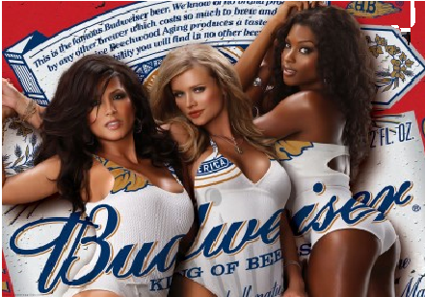
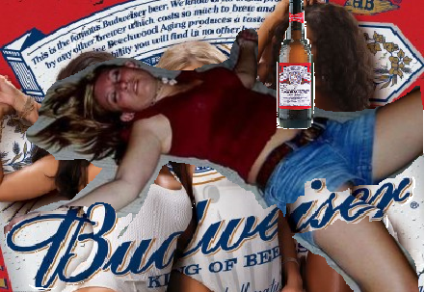
ALTERED

