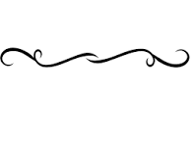

Quilt Square Symbols - You must choose three items to symbolize you.

Define the term “symbol” -

My three symbolic items are:
_______________________
_______________________
_______________________
Define the term “simile” –

Write three similes to explain your symbols:

- I am like a ______________________ because ______________________
_________________________________________________________________.

- I am like a ______________________ because ______________________
_________________________________________________________________.

- I am like a ______________________ because ______________________
_________________________________________________________________.

